1. Homepage View (index.html)

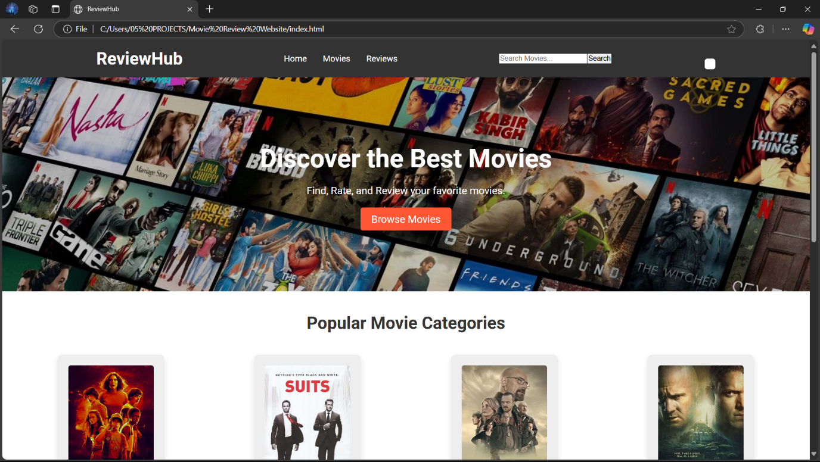

1. Extended view of Homepage (categories of movies).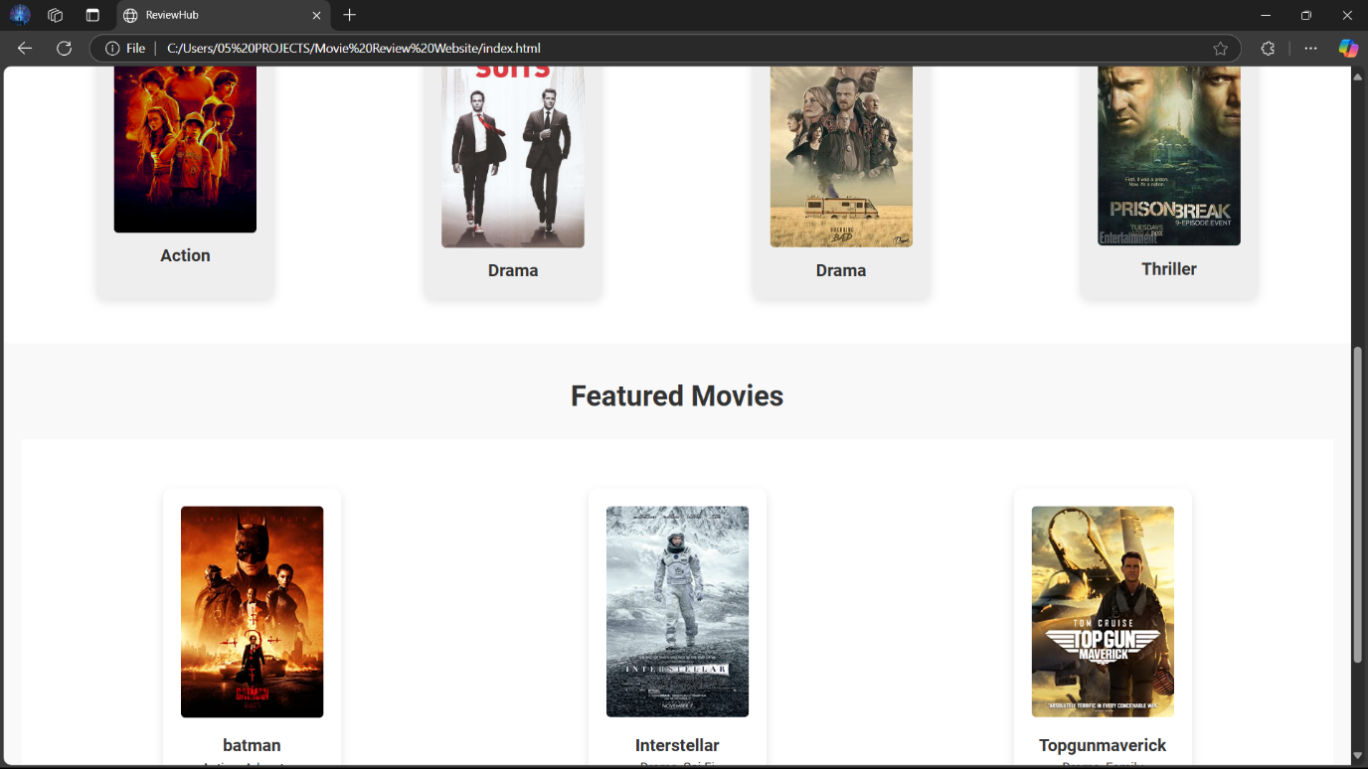
2. When search bar is used, movie if found -> returned, else -> movies name is returned.

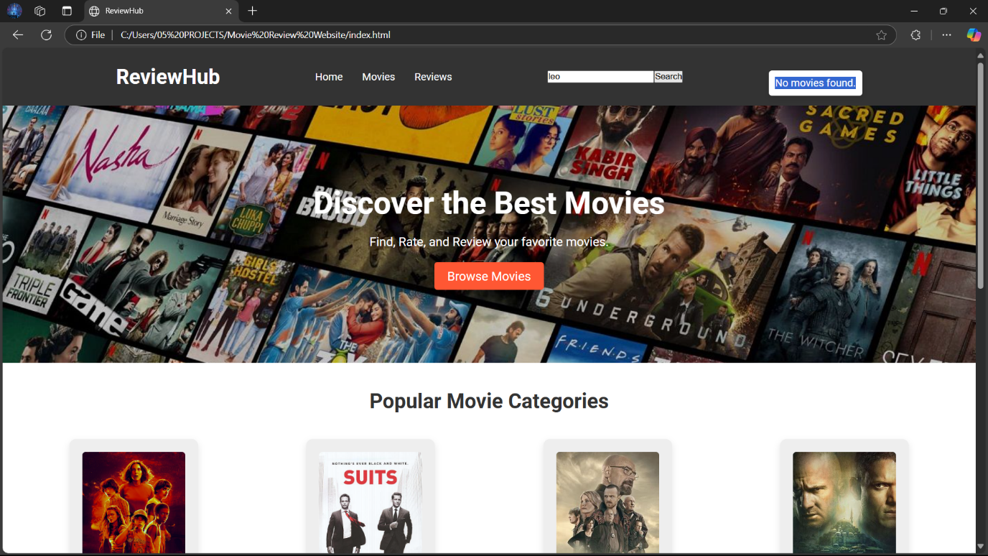

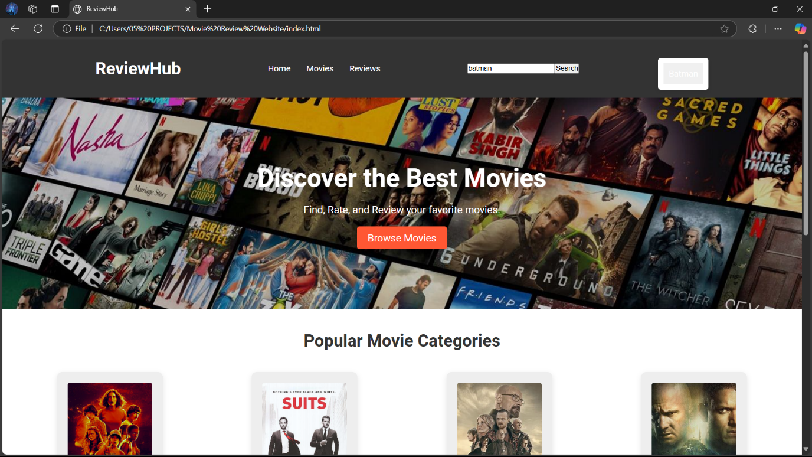

1. Browse movies in homepage gives the catalogue of available movies.

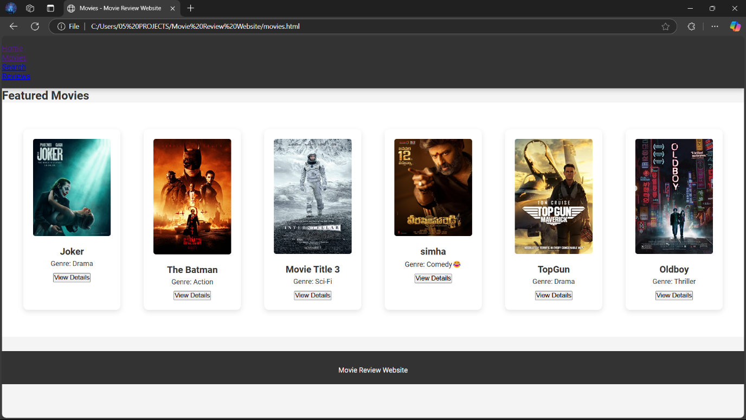

1. Review link in navbar goes to the review page of movies.

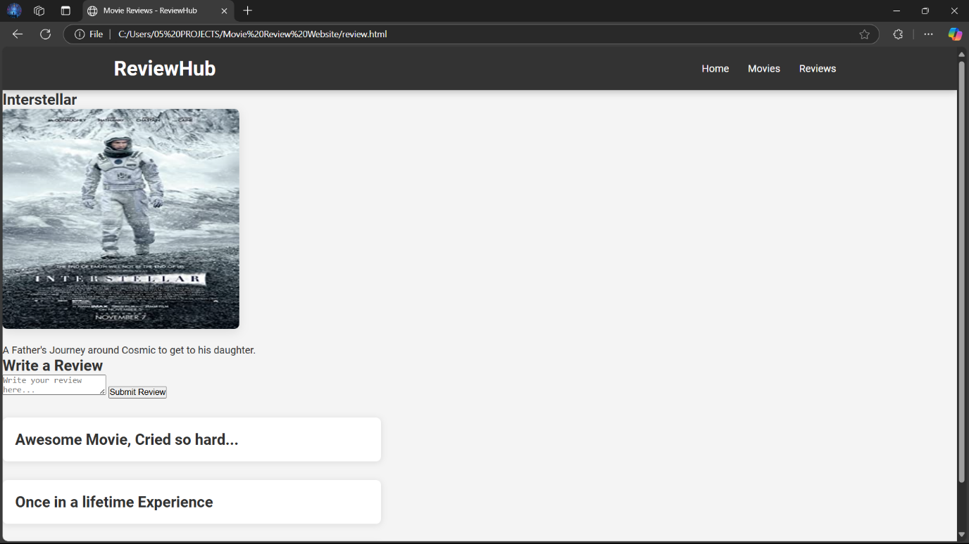

1. Write a review textbox enables the user to give reviews.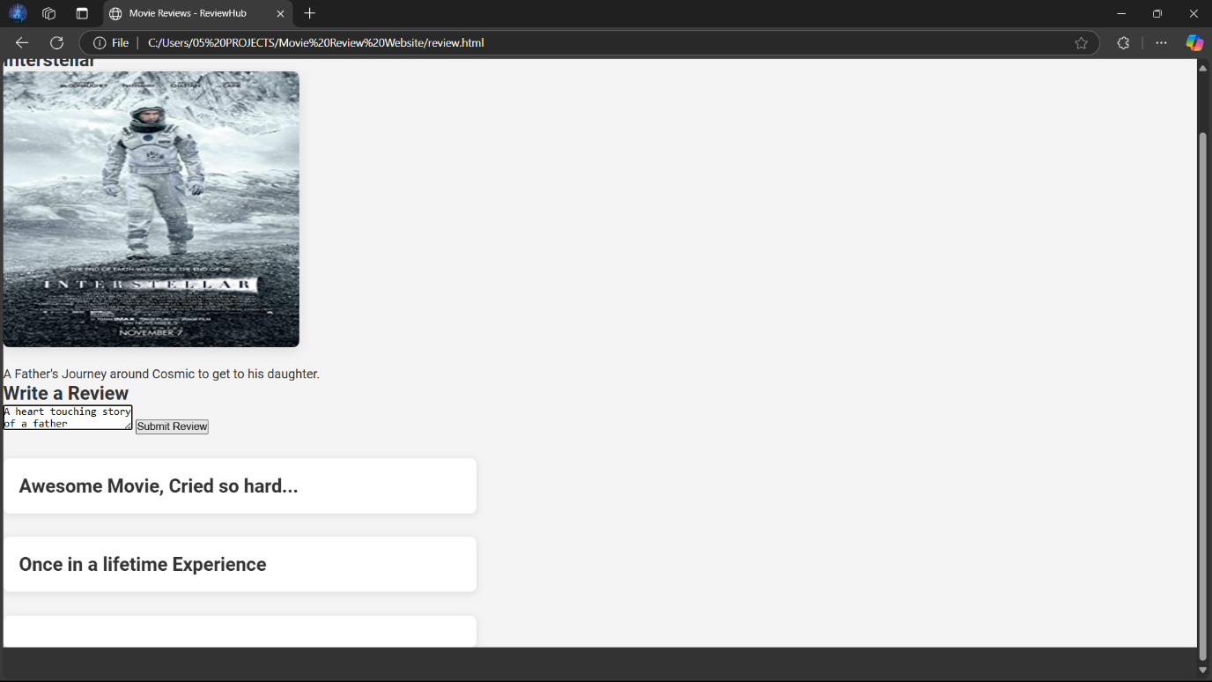
2. The Reviewhub button goes back to the homepage for navigation purposes.